## Introduction of Paul John Flory

Pan Yifan

Northeast Normal University

**Introduction:** Paul John Flory is a world-renowned polymer scientist whose contributions to polymer physics and chemistry span nearly every field (including polymerization kinetics and mechanism, molar mass distribution, solution thermodynamics and hydraulics, melt viscosity, glass formation, crystallization, chain structures, rubber elasticity, and liquid crystals). As an experimentalist and theorist, he is one of the main pioneers and founders of polymer science theory.

**Discussions:**

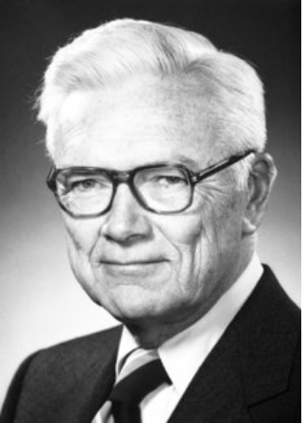If you’re interested in the field of polymer chemistry, you may be have heard of Paul J. Fory, who has a great reputation and has made many great achievements in this field. He is the one who deserves to be known and remembered, so in this artical, I’d like to introduce him to you in detail.

Paul John Flory, American chemist, truly the “founder of polymer science”, who , in his wide-ranging investigations, both theoretical and experimental, laid the foundation for the science of macromolecules, including major contributions to the theory of rubber elasticity. Additionally, the Nobel Prize in Chemistry 1974 was awarded to him for his fundamental achievements in the physical chemistry of the macromolecules. From this, we can find that his influence on the polymer field is extremely great. Then maybe you might wonder what his specific contributions are. Next, I’m going to go deeper to introduce three of his major achievements. The first one is he came up with the “Flory distribution”, which is a simple mathematical expression of molecular weight distribution in polymers. And this shows that the activity at the end of the polymer growing chain is only related to its local structure, and not to the length of the chain, that is, the size of the molecule. Besides, in the study of flexible polymer chain solution, Flory also found the temperature-solvent condition, θ-condition, in which the polymer form in the solution conforms to the Gaussian chain form and the thermodynamic properties of the solution conform to the ideal solution properties, by introducing the exclusion volume theory. This temperature is now known as the Flory temperature or θ-temperature, and the solvent is commonly referred to as θ-solvent. 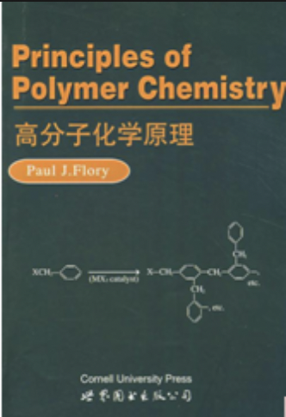Finally, I want to talk about is his contributions to the model of the chain structure of polymers. While teaching at Stanford University, Flory further studied the relationship between conformation and properties of long-chain molecules in polymers. He supplemented the theory of inner rotating isomers with the interaction of rotation in nearby bonds, which made the calculation of conformation reach the accuracy required for practical application. From the chemical structure of molecular chains, various values related to the conformation statistics of polymer chains can be calculated quantitatively. At the same time, the structure of macromolecules was mapped, which laid the foundation for the modern plastic industry. He also established the thermodynamic theory of crystallization of polymers and copolymers. Moreover, he wrote *Principles of Polymer Chemistry* and *Statistical Mechanics of Long Chain Molecules,etc.* Particularly, he wrote the *Principles of Polymer Chemistry* by refining and refining his lectures. Until now this book is still one of the essential reference books in the field of molecules and is widely used.

*Paul. John. Flory*

*Principles of Polymer Chemistry*

In conclusion, Flory's achievements in polymer science are almost unsurpassed. The polymer science he studies is relatively basic theoretical knowledge, but his research provides a theoretical basis for our current development and research of polymer materials. And his work not only promoted the development of polymer physics and chemistry, but also opened the way for the development of new polymers, and his research results, have been widely used in plastics, coatings, synthetic fibers and textiles, rubber and other fields, thus promoting the development of the daily chemical industry. Meanwhile, because of his analysis of the characteristics of biological macromolecules, he also made a corresponding contribution to the research and development of biology.

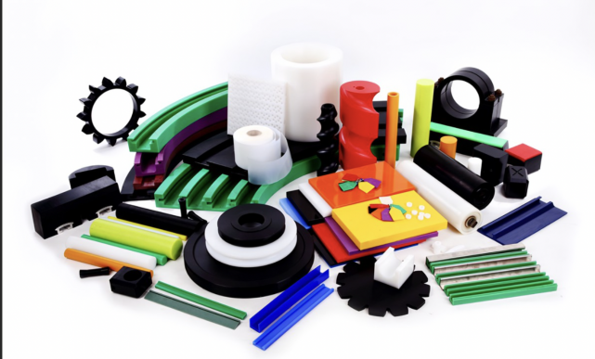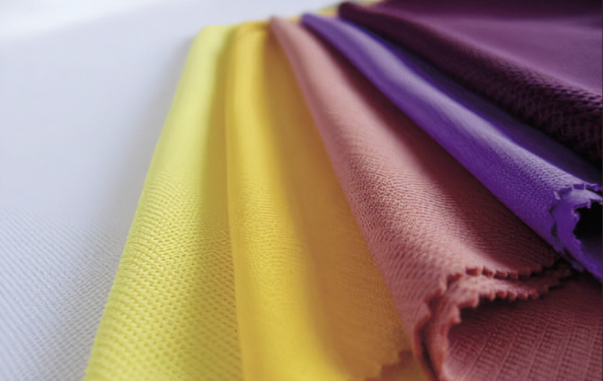After learning about his achievements, I’d like to introduce some of his basic background. Flory was born on 19 June, 1910, in Sterling. His father was Ezra Flory, a clergyman-educator; his mother, nee Martha Brumbaugh, had been a schoolteacher. Both were descended from generations of farmers in the New World. They were the first of their families of record to have attended college. And Flory graduated from the Department of Chemical Engineering at Manchester College in Indiana in 1931 and received a Ph.D. in physical chemistry at Ohio State University in 1934. He then worked for DuPont Company on basic polymer theory. After years as a professor at Cornell university in 1948. And in 1957 became Mellon, executive director of the institute of science. In 1961 as a chemistry professor at Stanford, retired in 1975. And he was elected a member of the National Academy of Sciences in 1953. But sadly, Flory died on September 8, 1985. From his life, we can find that hat he spent his life learning and making contributions to science.

*High polymer products*

Further, if you want to learn more about him, you can read the book *Paul John Flory: A Life of Science and Friends*. This book is the first full-length treatment of the life and work of Paul John Flory, recipient of the Nobel Prize in chemistry in 1974. It presents a chronological progression of his scientific, professional, and personal achievements as recounted and written by his former students and colleagues. This book covers the span of Flory's life, including a family history and reflections on the marks he left on the lives of various individuals within the scientific community. He 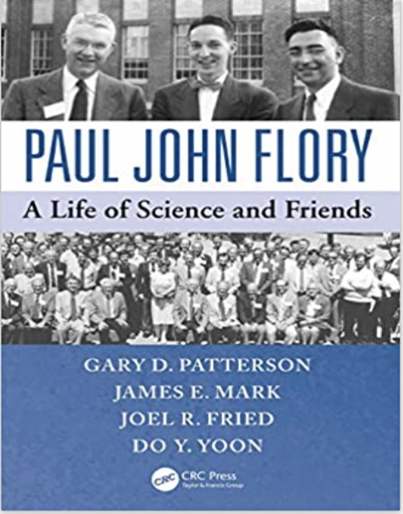played a major role in the consolidation of the macromolecular paradigm in chemistry, physics, and materials science. His influence permeates virtually every aspect of polymer science. The book includes an extensive collection of personal remembrances telling the circumstances under which colleagues worked with Flory, discussing their joint work, and assessing Flory's place in polymer science, chemistry, and world science. So if having a chance, we can read this book and from it we will know about a different Flory.

*Paul John Flory: A Life of Science and Friends*

**Conclusion:**

At last, I’d like to say that Flory's research has opened the door for polymer science. And his fundamental research has led to the development of our current understanding of polymers and the development of many new materials for our daily life and cutting-edge technology. Therefore, we have to admit that Flory's contribution to the development of polymer science is huge.

**References:**

[1]<https://chemistry.stanford.edu/people/flory>

[2]<https://www.nobelprize.org/nobel_prizes/chemistry/laureates/1974/flory-bio.html>

[3]https://www.amazon.cn/dp/1466595760

[4]*Paul John Flory: A Life of Science and Friends* **Author**: Gary D.Patterson、James E.Mark、Joel R.Fried、Do Y.Yoon